

Frankfurt University of Applied Sciences

Masters of Engineering

Information Technology

Course: Agile Development in Cloud Computing Environment

**Project: 3b Access Platform for Providers (APP)**

Authors:

Ankita Talande 1427349

**Table of Contents**

Abstract 5

1. Introduction 5

2. Scrum Methology 5

2.1 ScrumMaster 5

2.2 Product Owner 6

2.3 Development Team 6

2.4 Sprint 6

2.4.1 Sprint Planning: 7

2.4.2 Best Practices: 7

2.4.3 Push and Pull Techniques – 8

2.4.4 Collaboration – 8

2.4.5 Retrospective – 8

3. Kanban Board 9

4. Requirement 10

5. Software Architecture 11

6. Database Model 12

7. Usecase Diagram 12

8. Workflow 13

9. API Implementation - 13

9.1 API from others group 14

Group 2 API - http://35.174.107.106:3000/agreement 14

Group 4 API - http://13.48.42.106:8000/request-details/ 14

9.2 Our Group 3 API 14

9.3. Output 16

9.3.1 Screen 1: Login 16

9.3.2 Screen 2: Registration 17

9.3.3 Screen 3: Edit Profile 17

9.3.4 Screen 4: Master agreement 18

9.3.5 Screen 5: Master agreement bidding 20

9.3.6 Screen 6: Open Service 21

9.3.7 Screen 7: Onboard Employee 25

9.3.8 Screen 8: Employee status details 26

10. Conclusion 27

11. Reference 27

**Table of Figures**

Figure 1: Kanban Board

Figure 2: Task Status in Kanban Board

Figure 3: Subtask in Kanban Board

Figure 4: The usecase diagram for the provider in phase 1

Figure 5: The usecase diagram for the provider in phase 2

Figure 6: Provider

Figure 7: Provider Offers

Figure 8: Provider- User

Figure 9: Login

Figure 10: Registration

Figure 11: Homepage

Figure 12: Edit Profile page

Figure 13: Database information after editing profiles

Figure 14: Master Agreement Page

Figure 15: Master Agreement detail

Figure 16: Successfully Accepted the agreement

Figure 17: Agreement Bidding Details

Figure 18: Bidding details

Figure 19: Bidding successfully

Figure 20: Open service

Figure 21: Open service requests

Figure 22: Submitting the offers

Figure 23: Before submitting the offer

Figure 24: After submitting the offer

Figure 25: Details populated in console.

Figure 26: Details populated in database.

Figure 27: Adding new employee.

Figure 28: Information added in Database

Figure 29: Employee Status

# Abstract

"In recent years, the software development industry has been prominently shaped by the adoption of agile methodologies. Agile software development represents a collection of approaches emphasizing iterative development, wherein teams collaboratively craft solutions to problems. This process is facilitated by self-organizing, cross-functional teams. Notably, Scrum and Kanban stand out as two of the most prevalent Agile techniques. Our objective is to develop an application using agile methodologies, specifically designed to interact with other applications. This application will access master agreements and available services within the company, facilitating providers in extending offers to employees.

**Keywords:** Software Development, Provider Platform, Agile, Sprints, Iterative Methods, Scrum, Kanban.

# 1. Introduction

"Agile software development" embodies a spectrum of iterative methodologies where requirements and solutions evolve collaboratively within self-organizing, cross-functional teams. These methods foster a structured project management approach, advocating frequent inspection and adaptation. Embracing a leadership philosophy that emphasizes teamwork, self-organization, and accountability, Agile incorporates engineering best practices to enable the rapid delivery of top-notch software. Moreover, it aligns development processes with client needs and organizational objectives.

Within Agile, Scrum stands as a prominent subset—a popular and lightweight framework for agile development. Distinguished by its specific roles, artifacts, and time boxes, Scrum offers a structured approach that sets it apart from other Agile methodologies.

Kanban boards, on the other hand, serve as visual workflow tools engineered to streamline work processes and bolster productivity by curbing work-in-progress. This visualization tool enhances transparency, enabling the team to identify and address problematic work phases promptly. By fostering increased visibility, Kanban facilitates prompt solutions, ultimately enhancing team efficiency and effectiveness.

# 2. Scrum Methodology

In Scrum, three distinct roles — the ScrumMaster, the Product Owner, and the Development Team — collectively steer the process. These roles collaborate closely, ensuring seamless information exchange and swift problem resolution among their responsibilities.

## 2.1 ScrumMaster

The ScrumMaster shoulders multiple responsibilities aimed at streamlining the process, eliminating obstacles hindering productivity, and orchestrating crucial meetings. This role involves guiding the Product Owner in leveraging Scrum effectively to achieve their objectives and maximize return on investment (ROI). Encouraging empowerment and innovation among the development team to enhance their quality of work life is pivotal. Additionally, improving the team's productivity, refining engineering practices for potentially shippable increments, maintaining everyone's awareness of team progress, and keeping stakeholders updated fall under the purview of the ScrumMaster. Notably, the ScrumMaster acts as an educator and supporter for other roles, possessing in-depth Scrum knowledge.

The ScrumMaster remains vigilant about the project's status, comparing it to anticipated progress, resolving obstacles, and adapting swiftly to emerging challenges. As a liaison between stakeholders, the ScrumMaster shields the Team from external interferences, though task allocation remains the responsibility of the Team themselves.

## 2.2 Product Owner

The Product Owner stands as the custodian of criteria and requirements. Serving as the "single source of truth," they delineate requirements and their intended execution sequence for the Team. Acting as a bridge between the Team and business stakeholders, clients, and their product-related demands, the Product Owner manages inquiries about product requirements. They collaborate closely with the team to articulate user-facing and technical needs, document requirements, determine their implementation sequence, and curate an up-to-date and detailed Product Backlog. Moreover, the Product Owner assesses the readiness of implementations for release, ensuring the requisite functionality and quality, while also setting release timelines for finished work.

## 2.3 Development Team

Comprising self-organizing, cross-functional individuals, the Development Team undertakes the hands-on creation and testing of the product. Empowered to decide how to execute tasks, the Team is responsible for delivering the final output. Hence, the Team self-organizes, determining task allocation and division during Sprints. Ideally, the team size ranges between five to nine members to ensure optimal collaboration and productivity.

## 2.4 Sprint

Sprints define Scrum's iterative work periods, fostering consistency and swift feedback cycles. The shorter duration facilitates continual inspection and adaptation, crucial for efficient workflow management and reducing risks associated with longer cycles. Sprints follow a sequential pattern, immediately commencing after the conclusion of the preceding Sprint, maintaining a cadence for frequent iterations and feedback.

**2.4.1 Sprint Planning**

The project was planned into 5 sprints with 2week of sprint intervals as dated below:

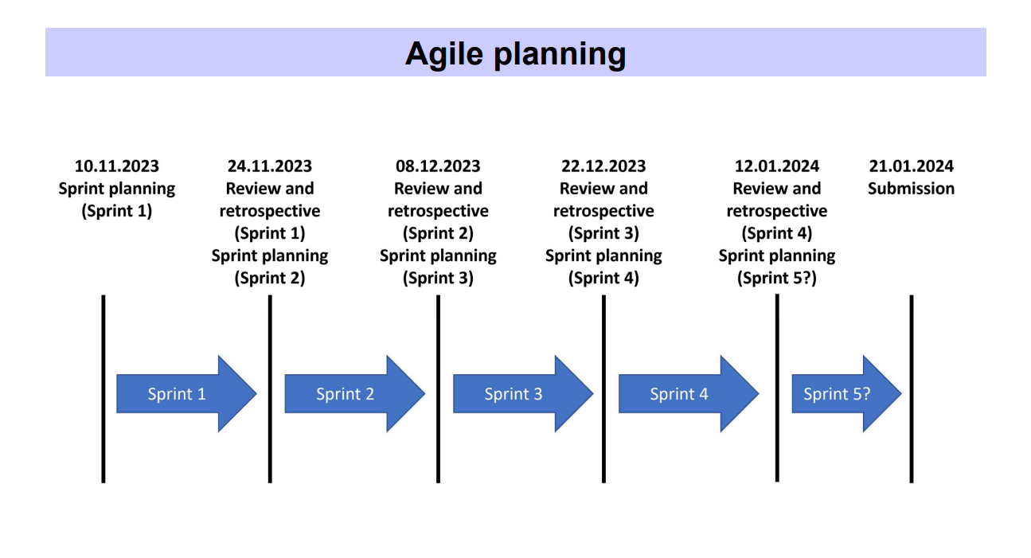

*Table1: Agile Planing*

Sprint 1: First major task in the sprint is Architecture design and pattern discussion. Edit profile and Logout -Frontend.

Sprint 2: Design of Login page and its sub fields on Frontend and Blackened, implementation of Nav-bar.

Sprint 3: Sharing of APIs created between group 1 and group 2 for open services agreement.

Sprint 4: Update the offered employee status with the response from project A (Profile Accepted/Rejected)

Sprint 5: Testing of data between group 2 and 4. Updating selected profile in database and fixing file path object.

### 2.4.2 Best Practices

After in-depth discussions between team members the decision was made to adopt a sprint interval of 2 weeks. This choice was driven by the advantages of managing smaller stories with limited requests, fostering the delivery of small, achievable goals, and allowing for increased iteration flexibility if needed.

Key outcomes included brief daily sprint meetings, two dedicated Product Backlog Refinement (PBR) sessions involving the Product Owner (PO), Backlog Owner (BO), and Team Members (TM). Additionally, a Team Demo was conducted to ensure that completed stories not only aligned with the initial requirements but also satisfied the PO, facilitating code review within the team. Sprint Reviews were crucial to ensuring proper closure of all stories and addressing any potential spillover stories.

Distinct responsibilities were assigned, encompassing the maintenance of sprint velocity and the management of appropriate backlog stories. The calculation of story points (SP) was collaboratively performed by the team during PBR sessions.

The 2 weeks were further broken down as:

|  |  |  |  |  |  |  |
| --- | --- | --- | --- | --- | --- | --- |
| Day 1  (Friday) | Day 2  (Saturday) | Day 3  (Sunday) | Day 4  (Monday) | Day 5  (Tuesday) | Day 6  (Wednesday) | Day 7  (Thursday) |
| Sprint Review | Product Backlog Refinement | Internal Group Meeting |  | Kanban Board update | Development work | Team Retrospective of sprint |
| Day 8  (Friday) | Day 9  (Saturday) | Day 10  (Sunday) | Day 11  (Monday) | Day 12  (Tuesday) | Day 13  (Wednesday) | Day 14  (Thursday) |
|  | Product Backlog Refinement Session2 | Team Retrospective of Sprint |  | Development work | Meeting with other groups | Team Demo |

*Table2: Sprint Planning*

### 2.4.3 Push and Pull Techniques

Adopting a pair programming approach with two members offered the team a unique application of the push and pull principle. Each Monday of the sprint served as a designated deployment day, where the code was introduced to the UAT Environment and subjected to a single round of testing, deviating from the conventional Continuous Integration and Continuous Development (CI/CD) pipeline. Post the sprint review, if everything proceeded as intended, the code was pushed to the PROD Environment. To prevent merge conflicts, only one team member handled the deployment, while others tested and provided input. Despite adhering to traditional practices, this method retained a notable degree of flexibility.

### 2.4.4 Collaboration

A designated representative from each team is encouraged to participate in these sessions, fostering a platform for teams to share overarching updates on their work, pinpoint impediments, and collaborate on potential assistance required from other teams. One example of such collaborative meetings is the Scrum session, employed to scale collaboration among teams.

In addition, Kanban boards play a vital role in aiding teams in collectively planning their work, visualizing progress, and maintaining focus on their individual goals.

### 2.4.5 Retrospective

Upon the conclusion of Sprint #1, the team exercised the flexibility to select a Story Point (SP) that optimized the full utilization of both Team Members' bandwidth. This determination emerged during the postmortem analysis conducted after the first sprint. A notable outcome of this discussion was the establishment and clarification of both the Definition of Done (DOD) and Definition of Readiness (DOR).

Traditionally, retrospectives were routinely held on the second Friday of each sprint.

# 3. Kanban Board

Teams can effectively visualize and control their operations using Kanban boards, employing cards to represent tasks visually. Each Kanban card includes comprehensive details about the task, such as the due date, assigned personnel, and a description of the work in progress.

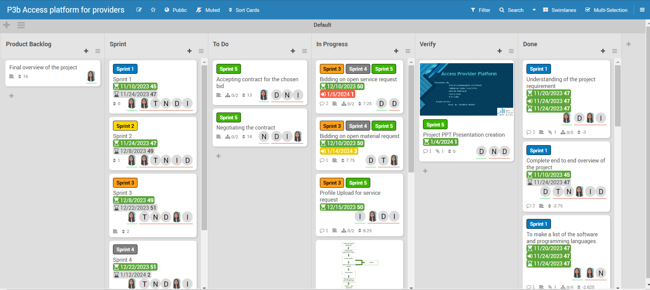

Figure : Kanban Board

**A product backlog** is a dynamic, prioritized list of tasks, features, and enhancements that a development team plans to work on in a product. It evolves over time, reflecting changing priorities and business needs. The backlog helps prioritize work, estimate effort, and provides visibility into upcoming tasks for efficient product development. Managed by the product owner, it serves as a living document in agile development.

**Task Name:** Clarity in task labels is crucial for understanding the nature of the work. Tasks that begin with a verb, like "Add functionality to web app," provide a high-level overview of the required work.

**Key Dates:** Depending on your team's process, certain dates may hold significance for both project managers and developers. For example, a project manager might need the task's start date, while a developer would require the task's deadline.

**Task Owner:** The designated task owner is responsible for ensuring that the job is completed. Any queries regarding the task should be directed to this individual.

**Task Status:** In the Kanban system, task status is often indicated by the card's location on the Kanban board. It is essential for everyone to be familiar with the various stages of your team's Kanban board, as each team may have a distinct process for tracking work in progress.

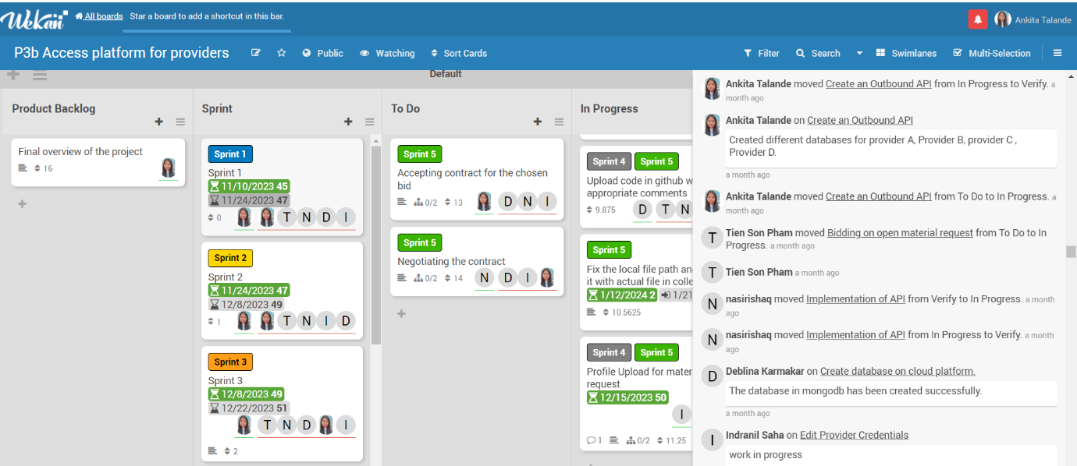

Figure : Task Status in Kanban Board

**Task Priority:** Illustrating the significance of an activity in relation to others is crucial. Setting priorities can help maximize lead time for tasks that demand it, assisting the development team in organizing their work effectively.

**Subtasks:** Some tasks may be sufficiently labor-intensive to warrant division into smaller subtasks. These subtasks can be linked to a parent task, contributing to a more organized workflow.

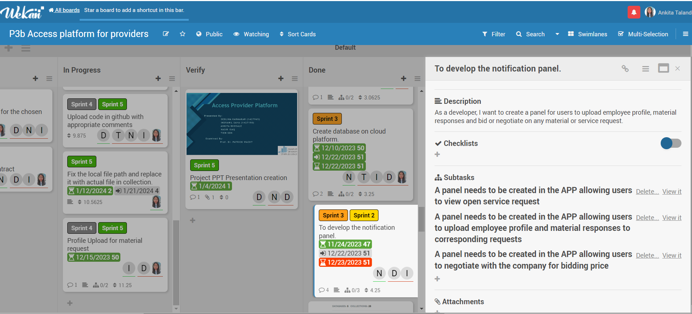

Figure : Subtask in Kanban Board

# 

# 4. Requirement

**General requirements:**

• User wants to login using authentication component.

• Provider Admin wants to edit provider credentials (name).

• Provider Admin wants to configure user management for provider (register new user, deregister user).

• User wants to see the offers of the company “future-X” regarding master agreement types (example: technology-based).

• User wants to provide an offer to establish a master agreement.

• User wants to bid on open service requests and material request.

• User wants to upload profiles of employees for service requests and responses to material requests.

• User wants to make suggestions based on the knowledge of each offered employee.

• User accepts contract if his offer has been chosen. Negotiation can take place.

• Further specification takes place during collaboration with the customer.

• APIs need to be provided to other groups.

# 5. Software Architecture

We utilized Node.js as the backend for our provider platform application, and for crafting the user interface, we employed JavaScript along with Pug CSS. The following table outlines the packages and their respective versions employed in our Node.js environment. To install these packages, we executed the 'npm install' command, and to launch the application in the terminal, we initiated the 'npm start' command.

|  |  |
| --- | --- |
| **Name** | **Version** |
| **Bcryptjs** | **^2.4.3** |
| **connect-flash** | **^0.1.1** |
| **cookie-parser** | **~1.4.4** |
| **Cors** | **^2.8.5** |
| **Debug** | **~2.6.9** |
| **Express** | **~4.16.1** |
| **express-ejs-layouts** | **^2.5.1** |
| **express-session** | **^1.17.3** |
| **express-validator** | **^6.14.2** |
| **http-errors** | **~1.6.3** |
| **Mongoose** | **^6.8.1** |
| **Morgan** | **~1.9.1** |
| **Multer** | **^1.4.5-lts.1** |
| **Passport** | **^0.6.0** |
| **passport-local** | **^1.0.0** |
| **Pug** | **2.0.0-beta11** |
| **node-fetch** | **^2.6.7** |
| **serve-favicon** | **^2.5.0** |

*Table 3: Packages list*

# 6. Database Model

Mongodb Atlas is being utilized by us. A separate database is maintained for each provider. The collections available for each provider include Agreements, Bids, Employees, Offers, OpenServiceRequests, and Users.

# 7. Usecase Diagram

This diagram illustrates the use case for the provider in phase 1. Following registration, the provider can log in. Once logged in, the provider can modify personal details and access the master agreement provided by the company. The provider can request daily rates and has the option to accept or reject master agreements. After accepting, the provider can then bid for active master agreements.

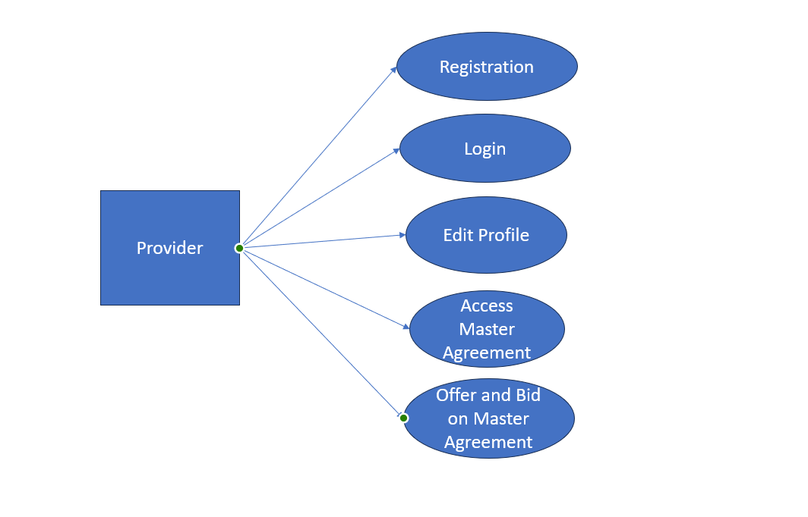

Figure : The usecase diagram for the provider in phase 1

This use case diagram represents the provider's functionalities in phase 2. During this phase, the provider can access open service requests from the company, aligning with the accepted master agreements. The provider is equipped with the capability to create employees and extend offers to them based on the existing open requests. 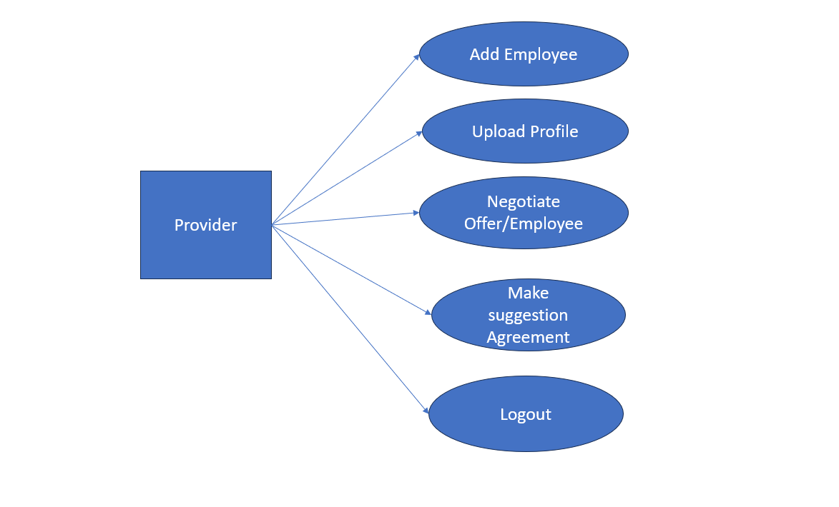

Figure : The usecase diagram for the provider in phase 2

# 8. Workflow

The project is structured around two key phases. In the initial phase, the company is dedicated to generating and disseminating new master agreements for various offers. Providers have the privilege of accessing these master agreements, enabling them to make decisions by either accepting or rejecting the offers. Within this phase, providers can also define parameters for daily rate limits, and the master agreements automatically conclude after a specified time interval.

Moving into the second phase, the company focuses on creating service requests for employees to be fulfilled by providers. Following the service evaluation, providers extend offers to employees, and a negotiation process ensues.

# 9. API Implementation -

## The application is designed to fulfill the requirement of sending and accessing APIs with compatibility across various development platforms.

## 9.1 API from others group

### Group 2 API - <http://35.174.107.106:3000/agreement>

### Group 4 API - <http://13.48.42.106:8000/request-details/>

## 9.2 Our Group 3 API

Offers to Open Service Request -

<http://ec2-54-147-16-17.compute-1.amazonaws.com:4000/users/offers?provider=A>

<http://ec2-54-147-16-17.compute-1.amazonaws.com:4000/users/offers?provider=B>

<http://ec2-54-147-16-17.compute-1.amazonaws.com:4000/users/offers?provider=C>

<http://ec2-54-147-16-17.compute-1.amazonaws.com:4000/users/offers?provider=D>

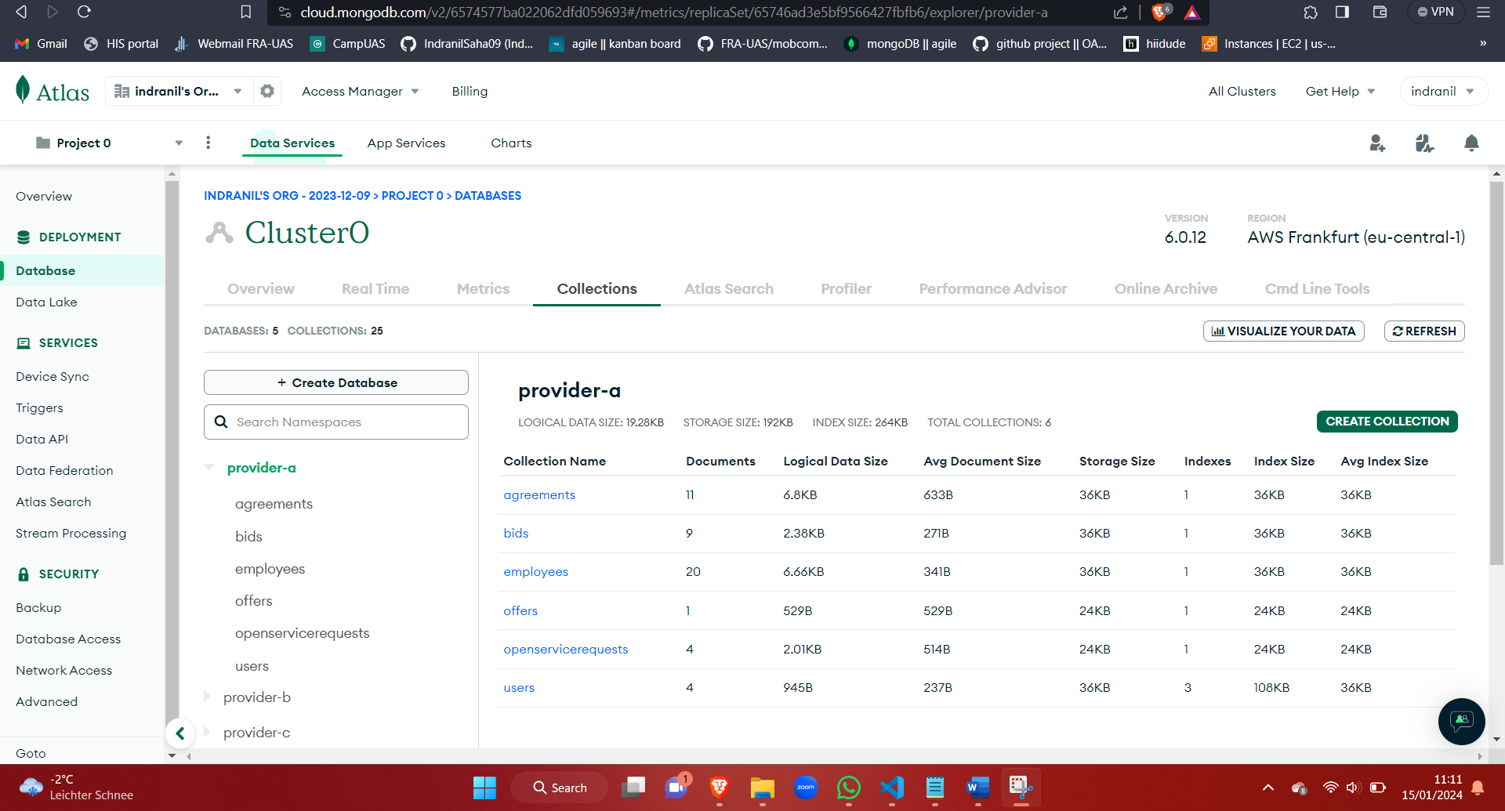

Figure : Provider

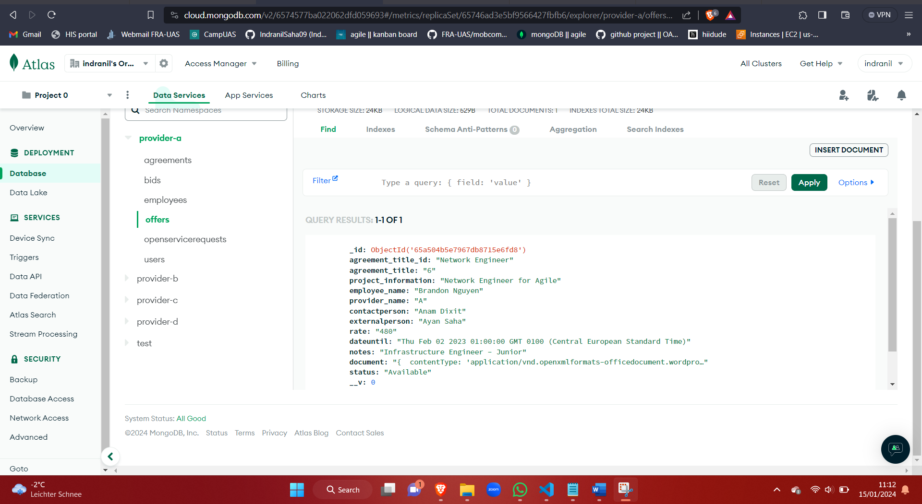

Figure : Provider Offers

Master Agreement Bids –

<http://ec2-54-147-16-17.compute-1.amazonaws.com:4000/users/Agreementbids?provider=A>

<http://ec2-54-147-16-17.compute-1.amazonaws.com:4000/users/Agreementbids?provider=B>

<http://ec2-54-147-16-17.compute-1.amazonaws.com:4000/users/Agreementbids?provider=C>

<http://ec2-54-147-16-17.compute-1.amazonaws.com:4000/users/Agreementbids?provider=D>

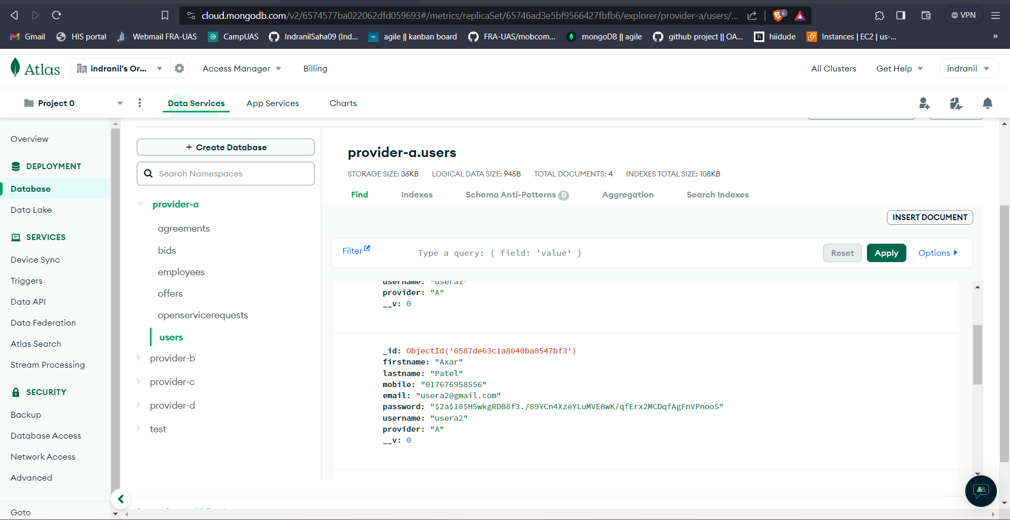

Figure : Provider- User

## 9.3. Output

To run the application – npm install, npm start

To run the application locally - <http://localhost:4000/>

To run application in cloud – host it in cloud platform and run it

Using this Link, we can access our provider access platform.

### 9.3.1 Screen 1: Login

Home page -

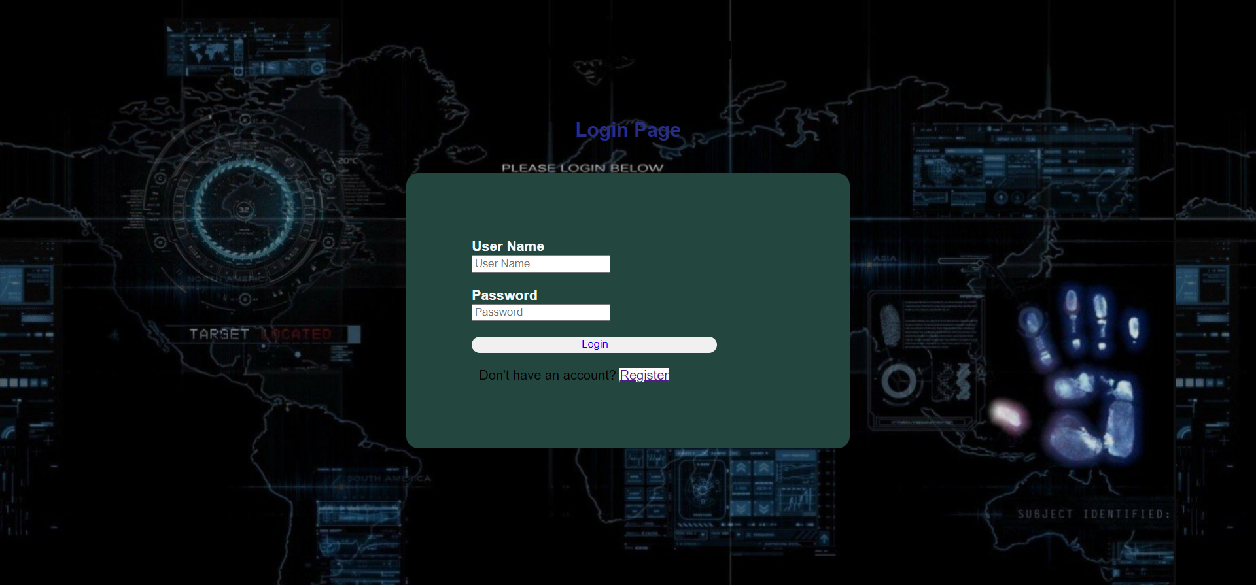

Figure : Login

Enter proper credentials to login

Logging in as user of provider-a

### 9.3.2 Screen 2: Registration

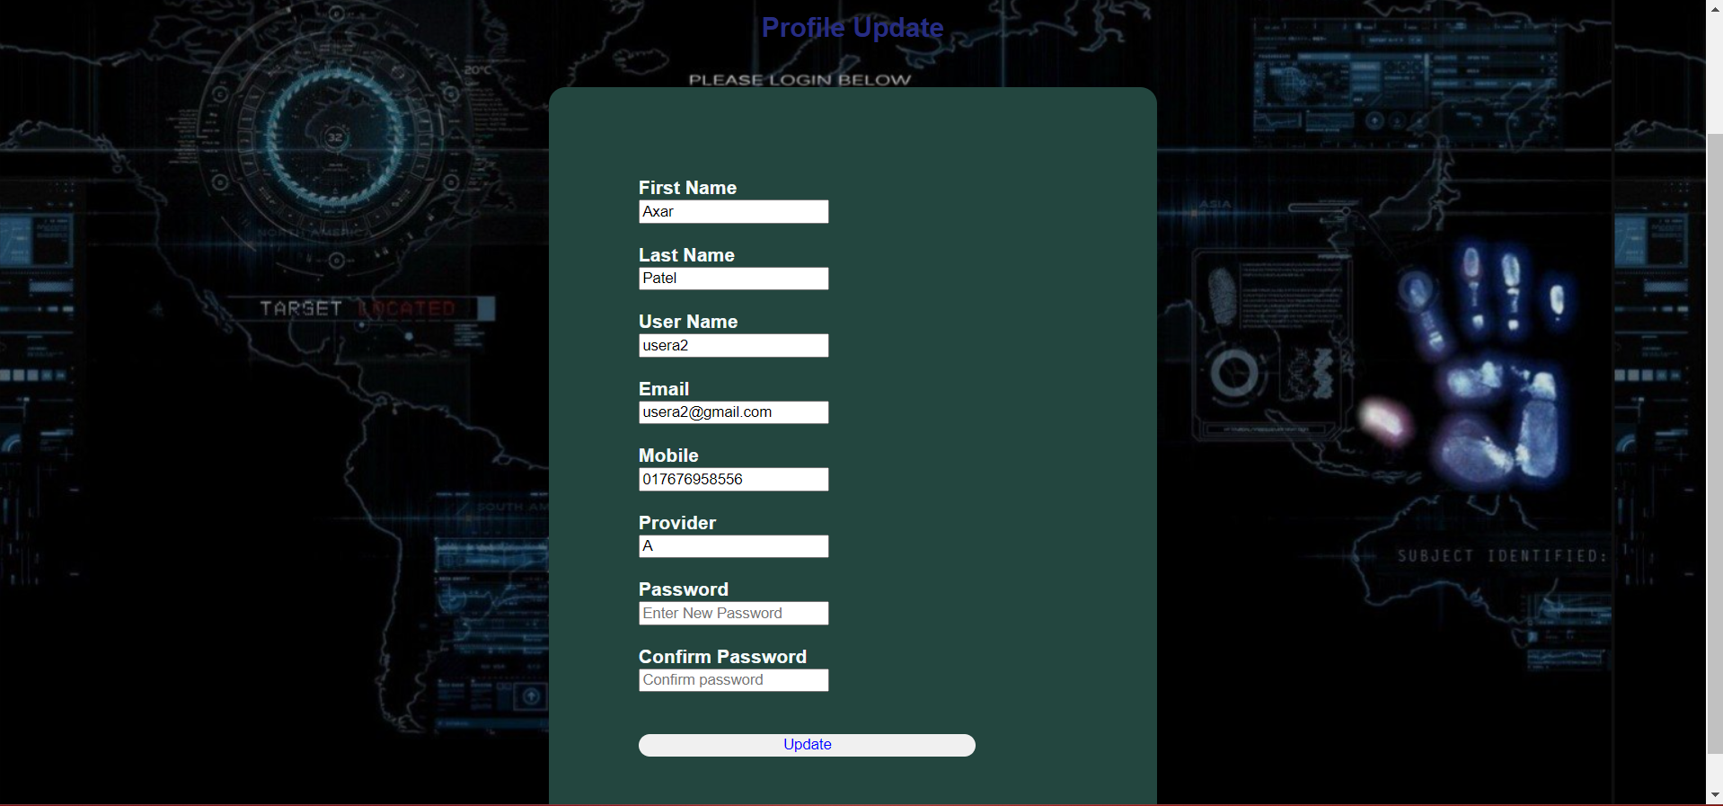

Figure : Registration

### 9.3.3 Screen 3: Edit Profile

Providers can edit the personal details which are provided during the registration process. Once they have edited, using the new details provided they can be able to login and able to access the provider platform.

To edit user profile

Click on Edit Profile in dashboard

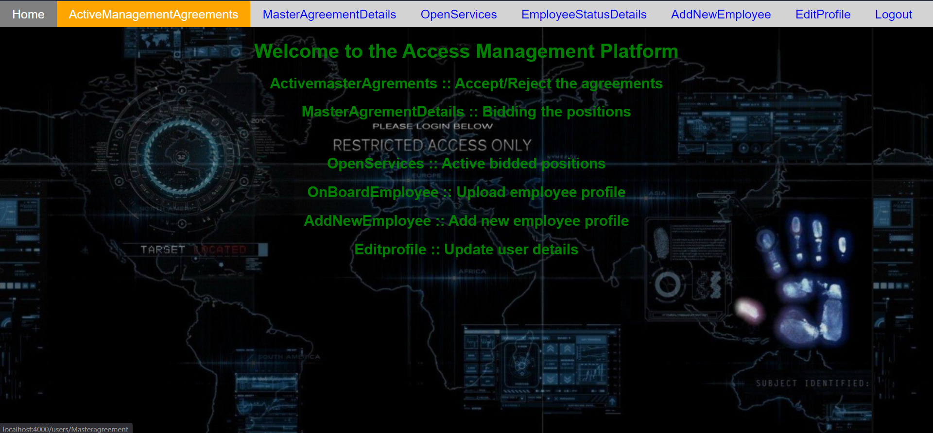

Figure : Homepage

Changed mobile number field, enter username and password and click on update

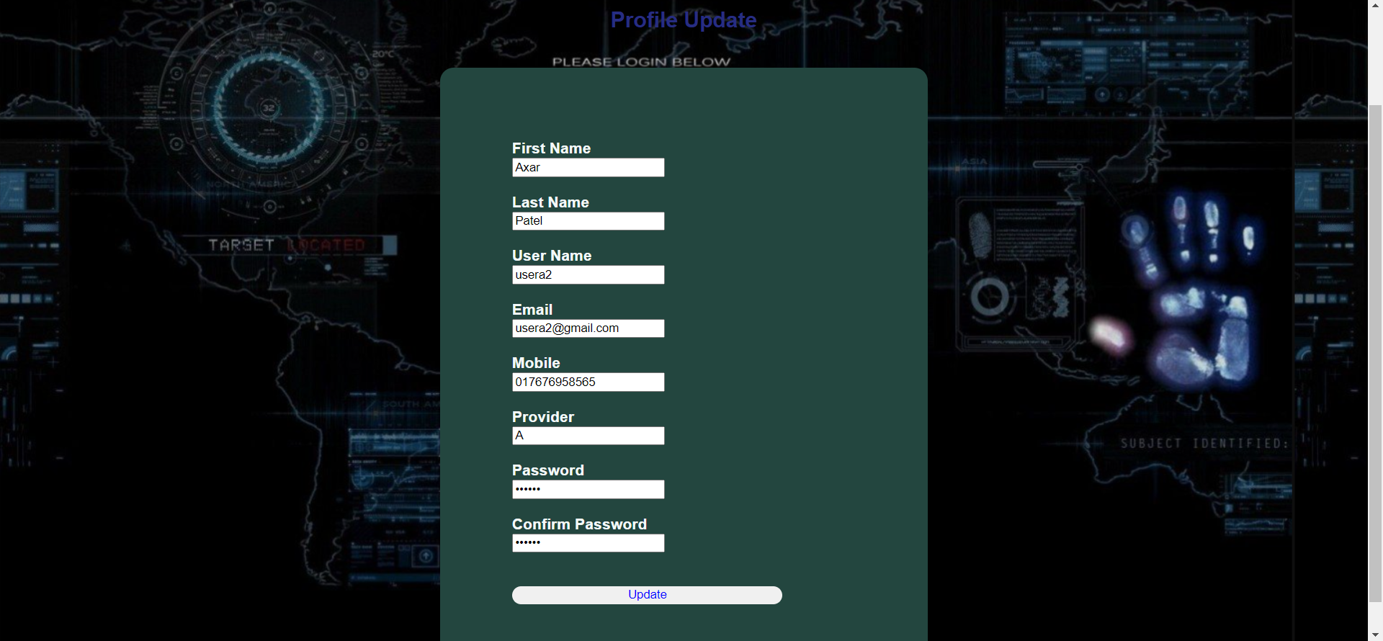

Figure : Edit Profile page



Figure : Database information after editing profiles

### 9.3.4 Screen 4: Master agreement

Click on ActiveManagementAgreements to get the master agreements published from group 2

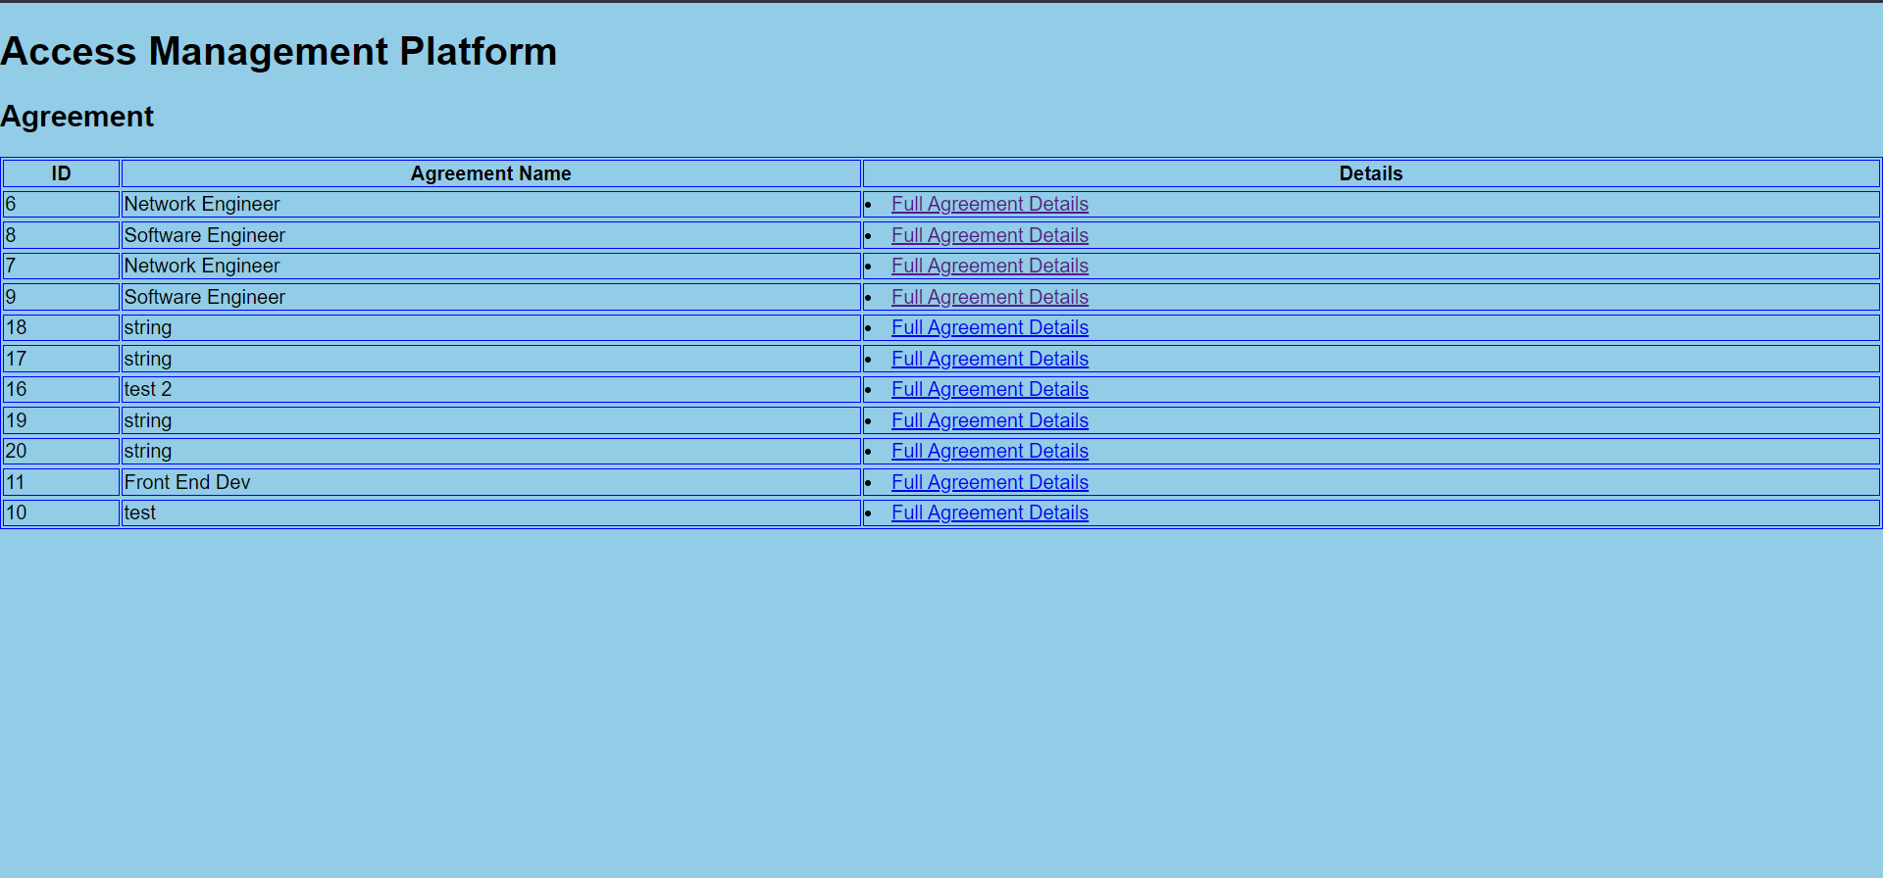

Figure : Master Agreement Page

Click on Full Agreement Details to view the total agreement details

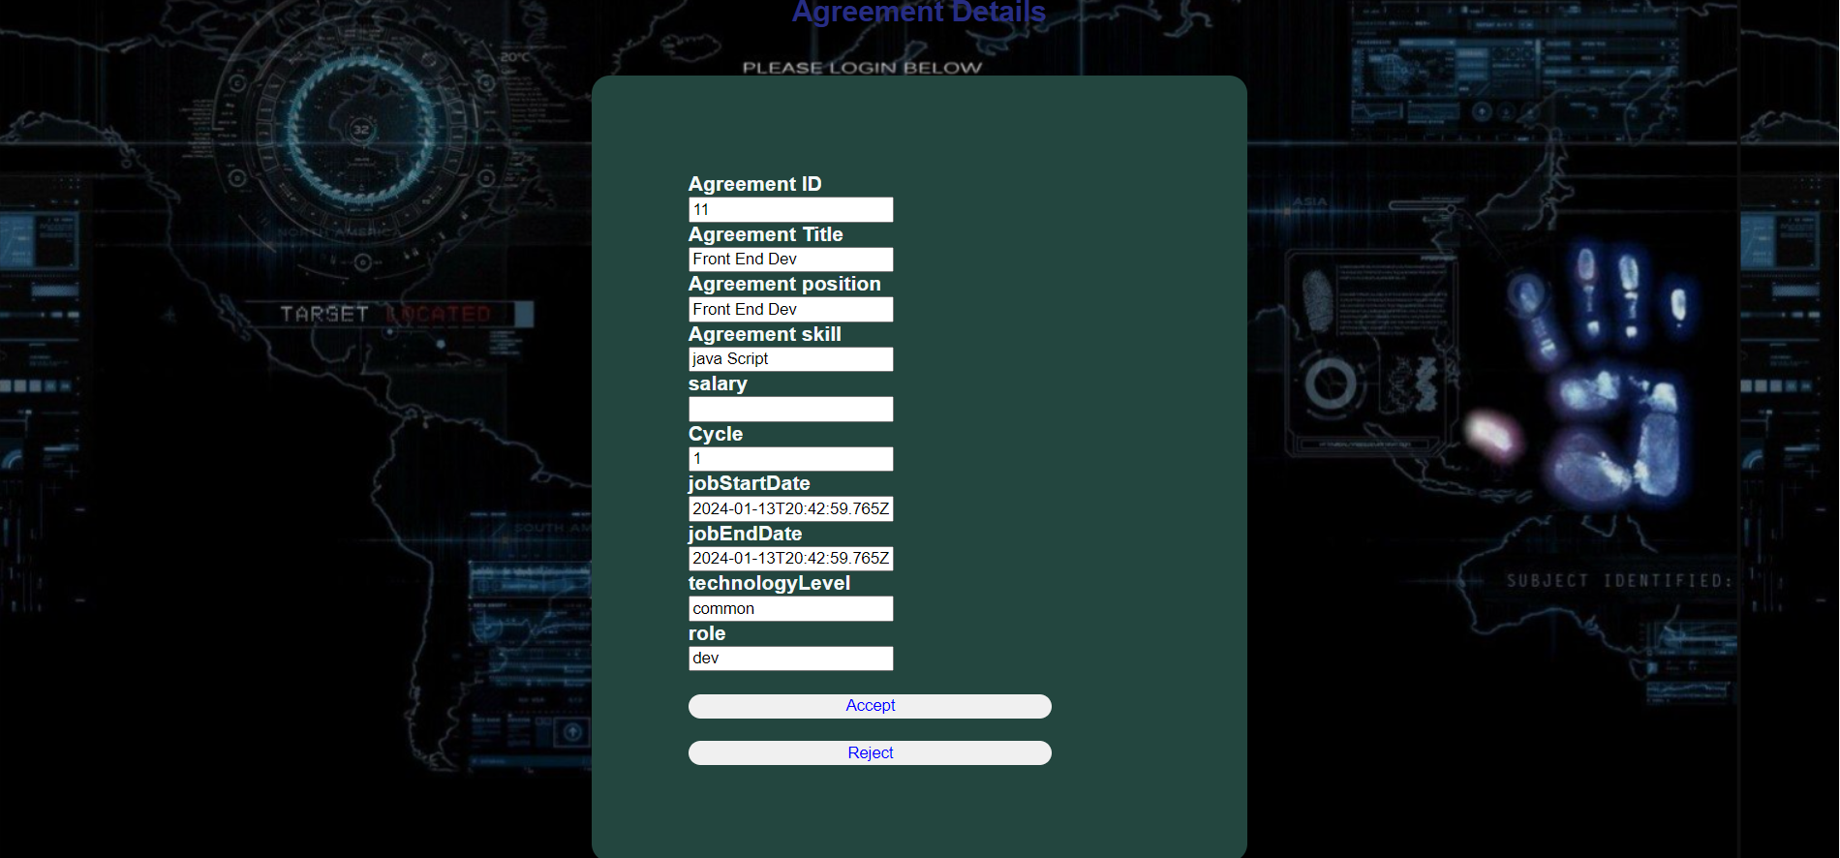

Figure : Master Agreement detail

Enter the salary field and click on accept

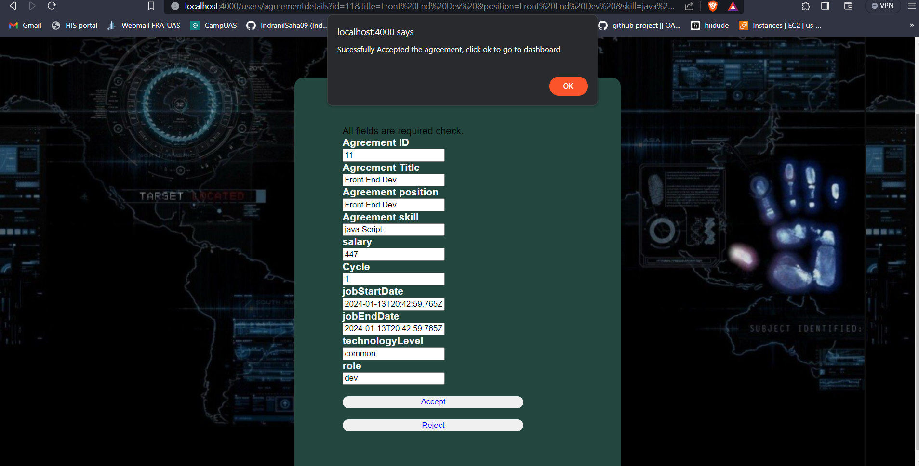

Figure : Successfully Accepted the agreement

Click ok to go to dashboard

Click on MasterAgreementDetails to view the accepted master agreement

### 9.3.5 Screen 5: Master agreement bidding

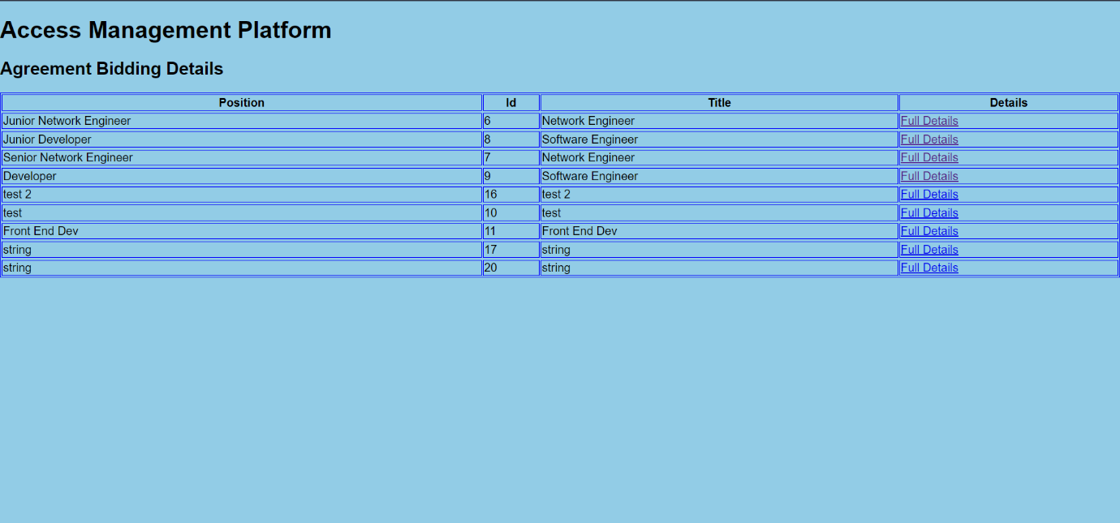

Figure : Agreement Bidding Details

Click on full details to view details

Fill in proper details and bid for the agreement

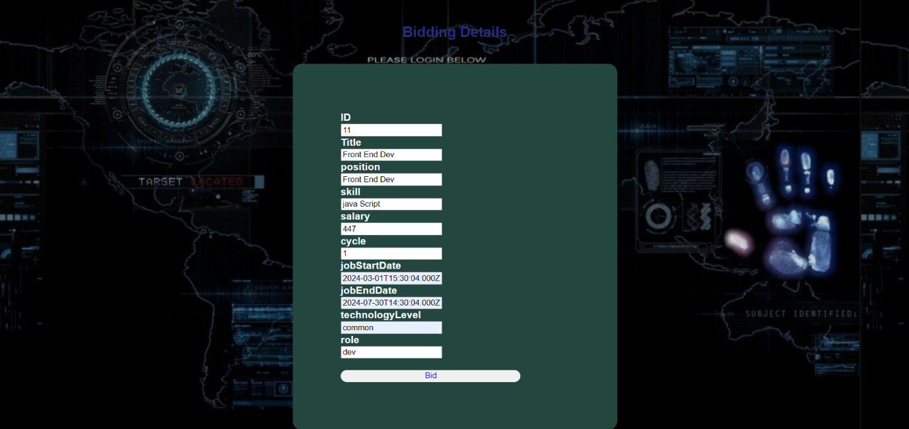

Figure : Bidding details

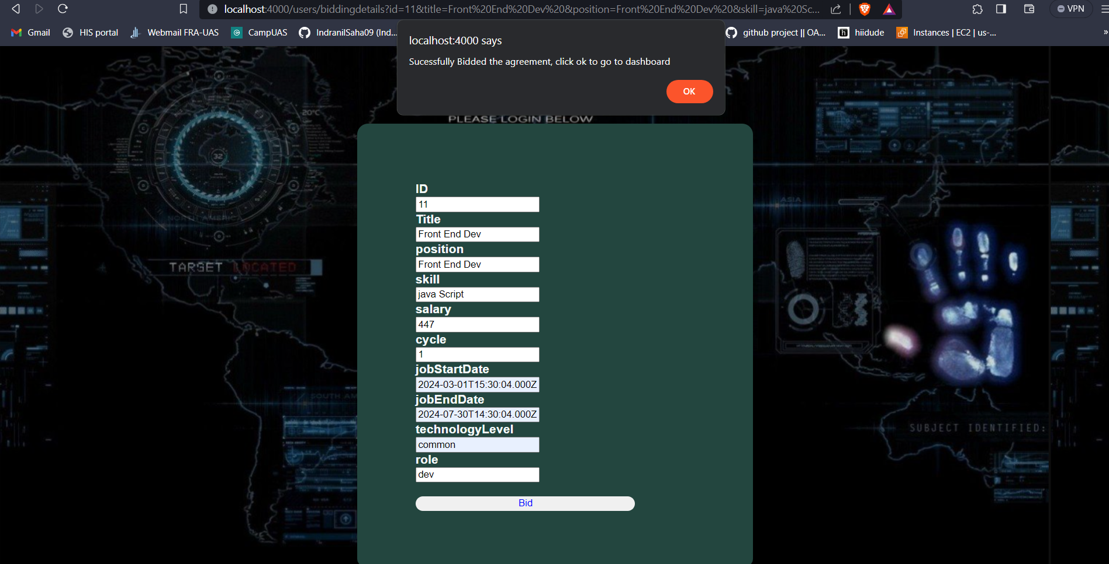

Figure : Bidding successfully

Click on OK to dashboard

### 9.3.6 Screen 6: Open Service

Click on OpenServices

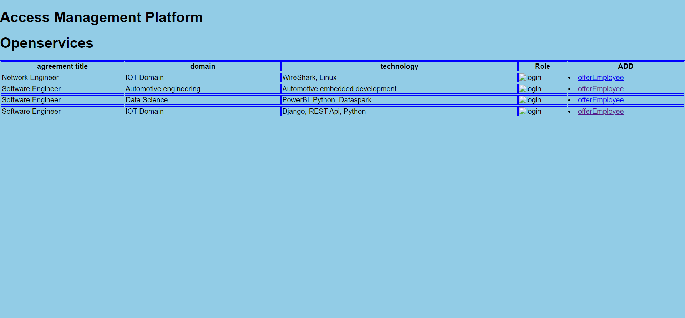

Figure : Open service

Click on offerEmployee to offer an employee against a open service request

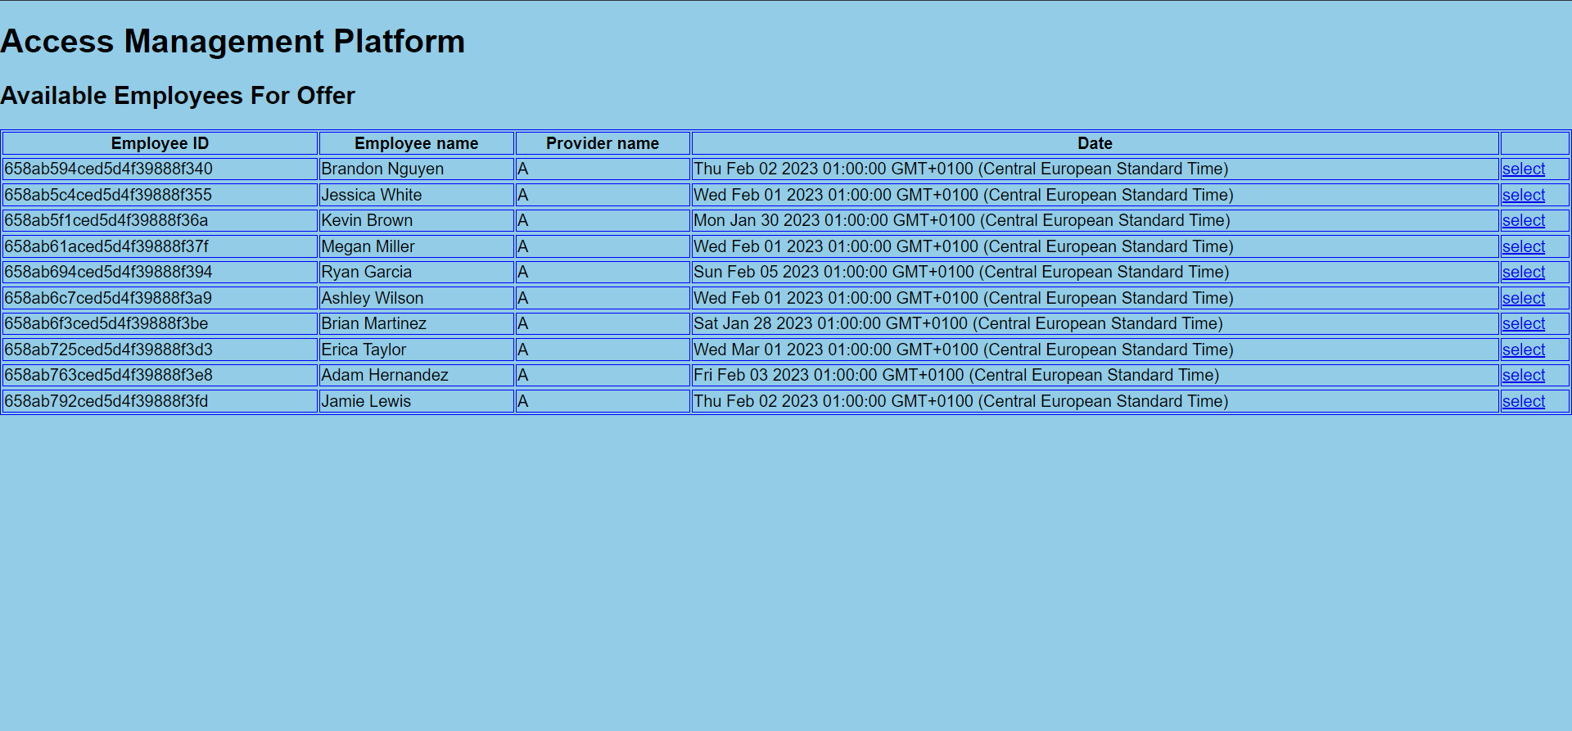

Figure : Open service requests

Click on select

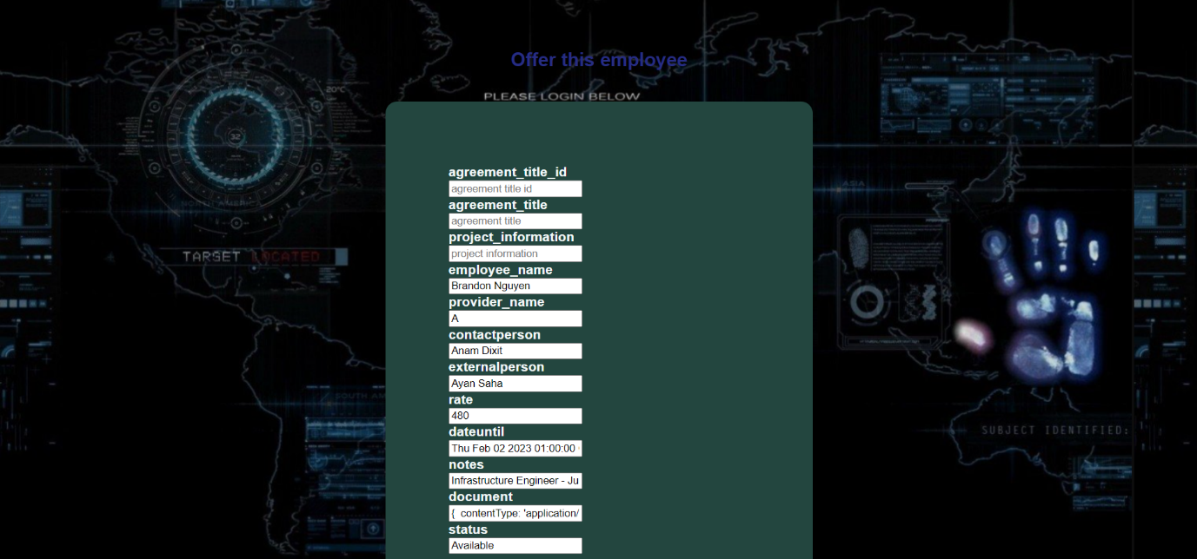

Figure : Submitting the offers

Fill proper details and submit the offer

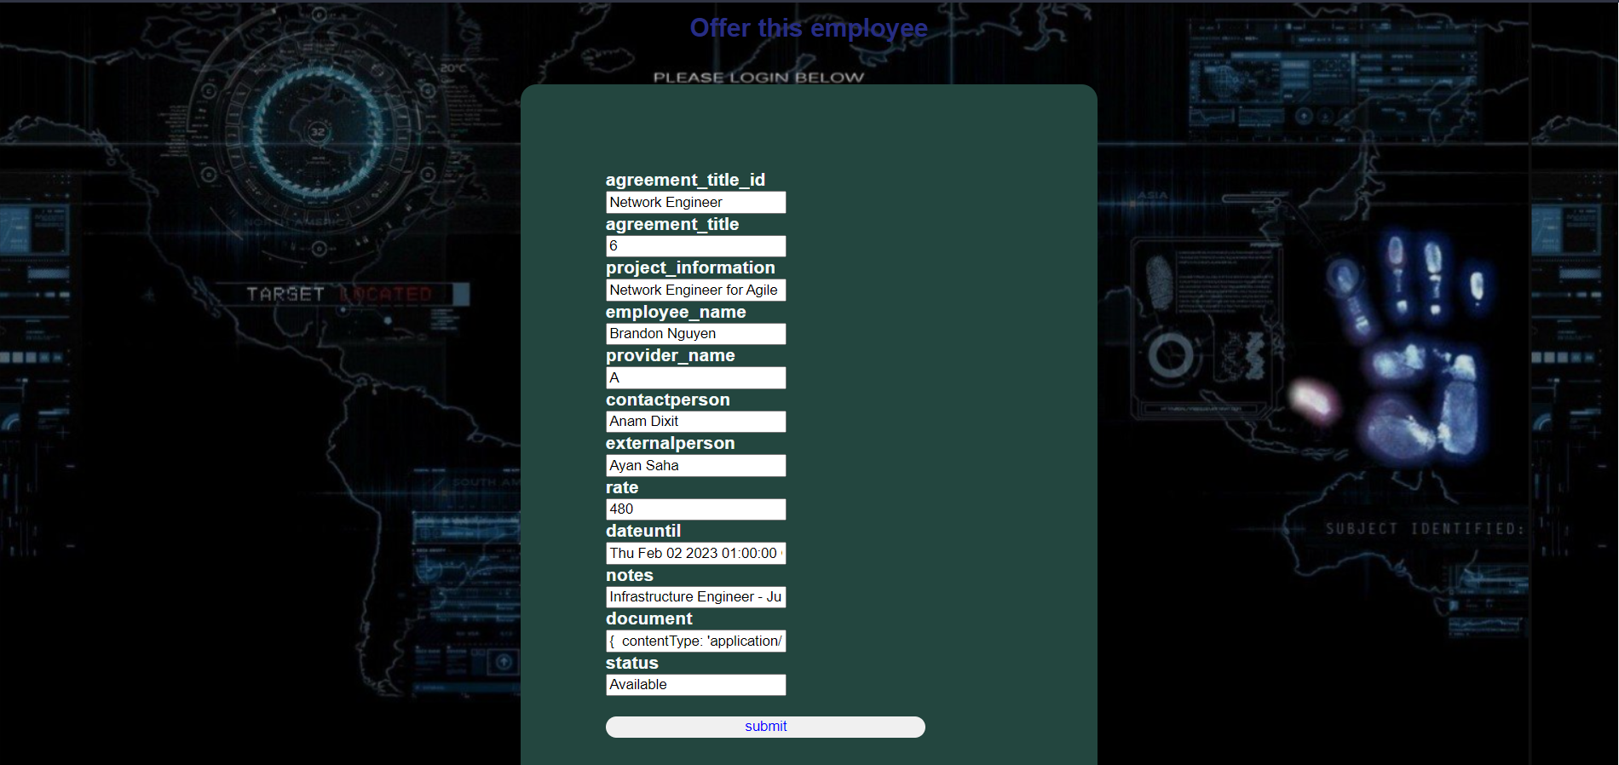

Figure : Before submitting the offer

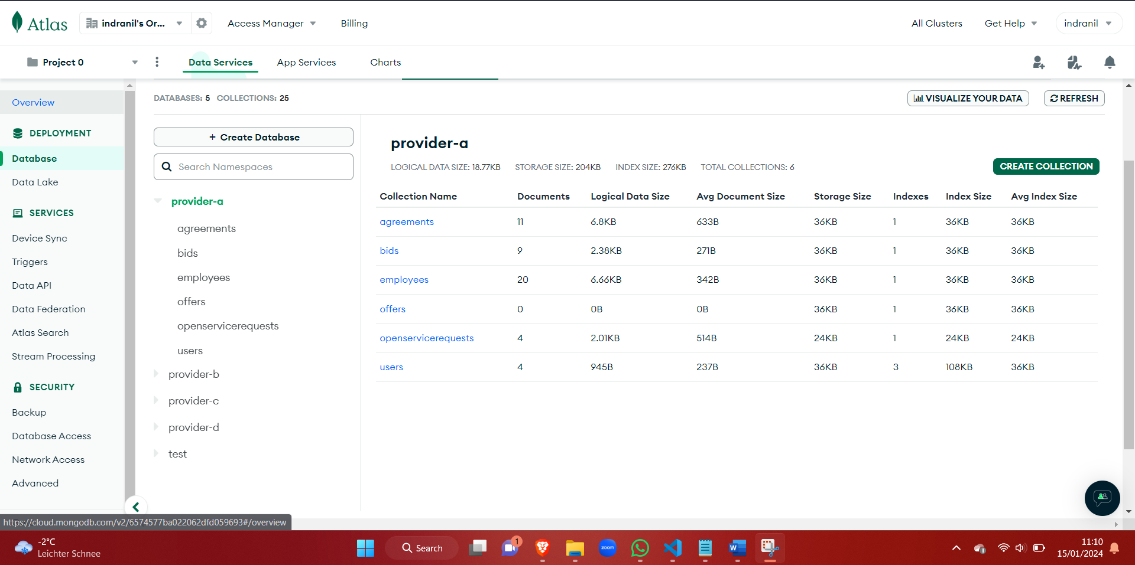

Figure : After submitting the offer

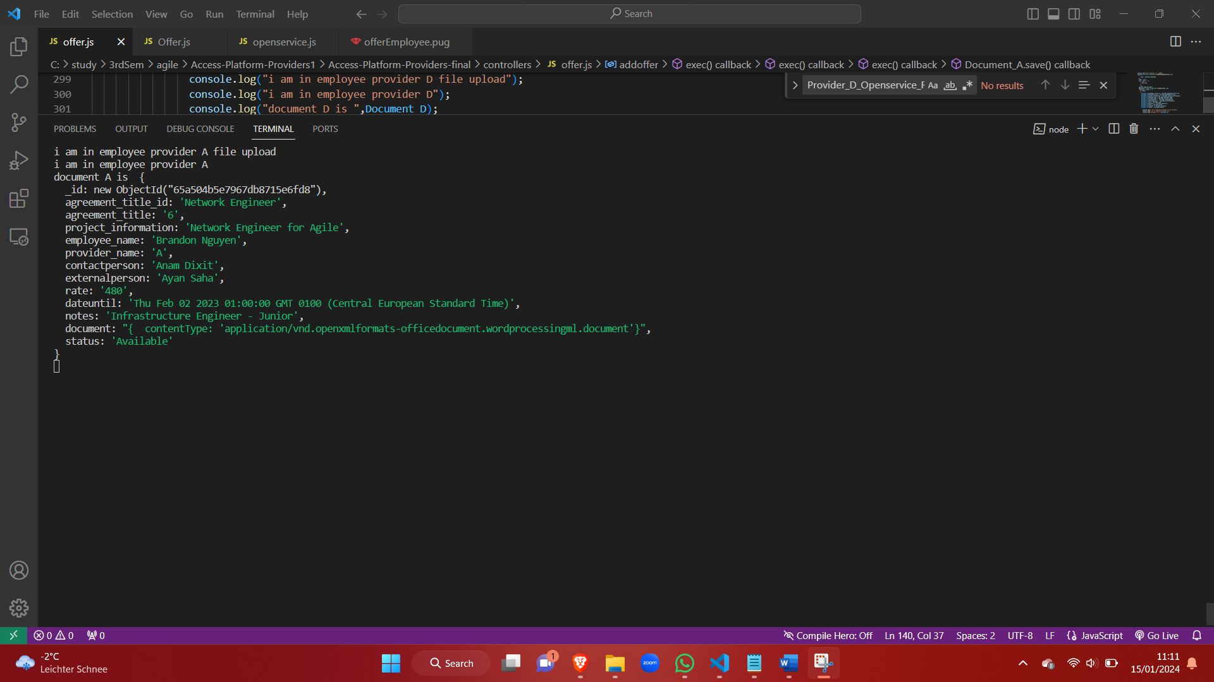

Figure : Details populated in console.



Figure : Details populated in database.

### 9.3.7 Screen 7: Onboard Employee

For Adding new employee for the provider

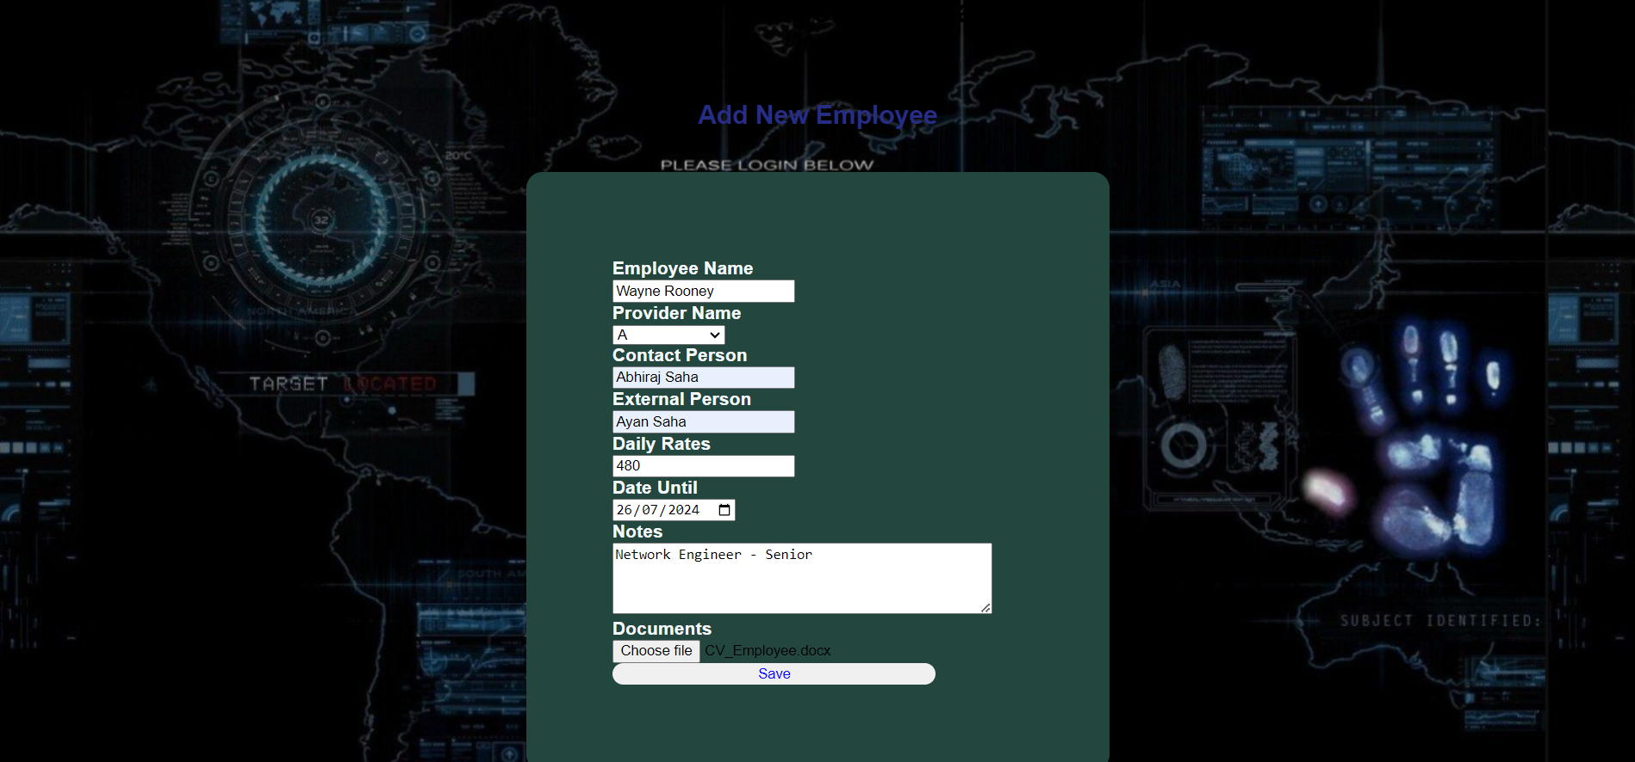

Figure : Adding new employee.

Fill up with proper details and click on save

On clicking Save, it redirects to dashboard

Details also added in database

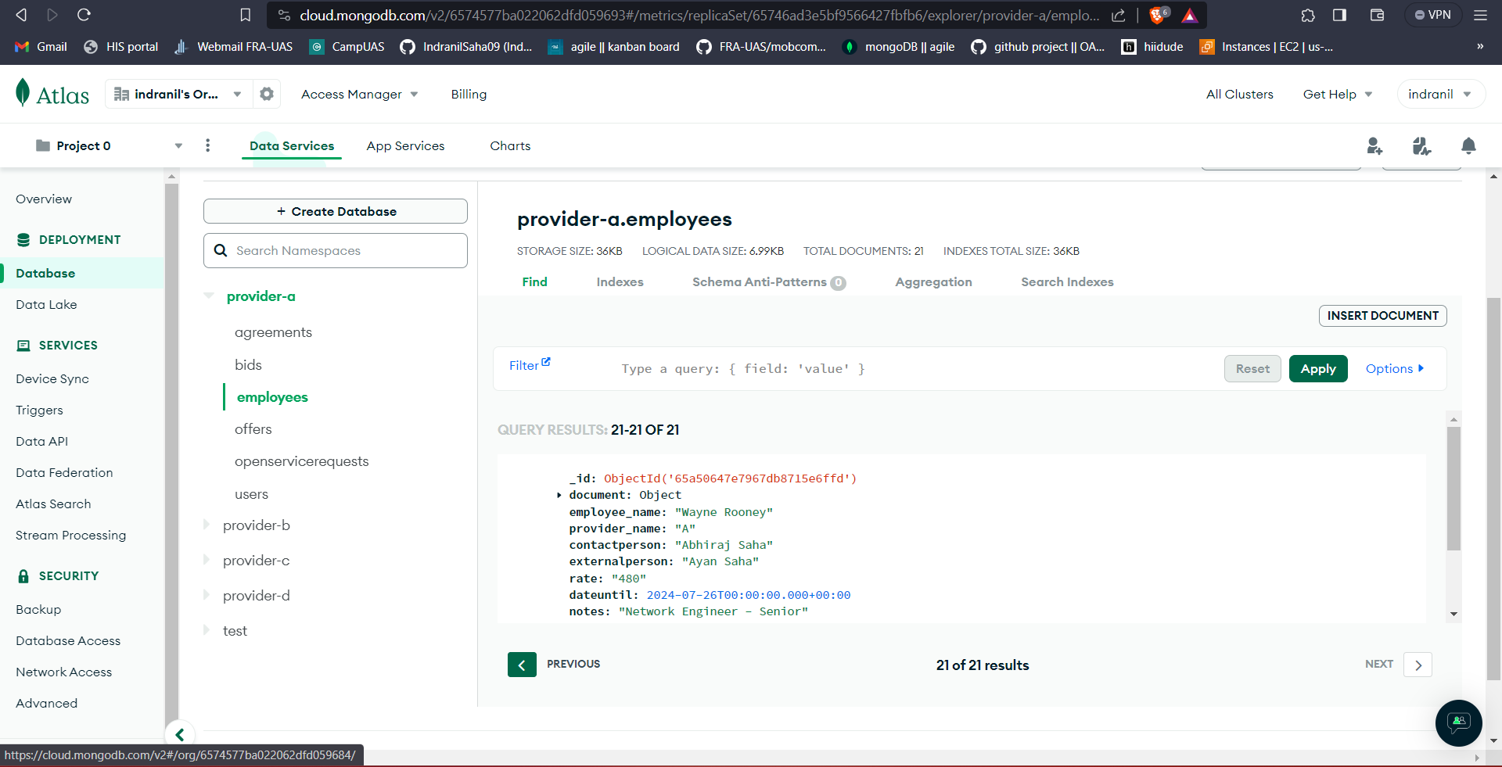

Figure : Information added in Database

### 9.3.8 Screen 8: Employee status details

Click on EmployeeStatusDetails

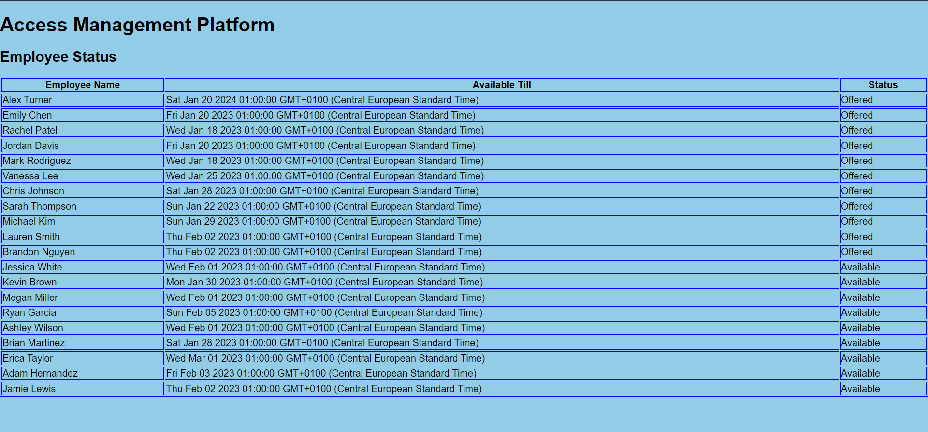

Figure : Employee Status

# 10. Conclusion

We created an application designed to facilitate access to the master agreement and initiate service requests based on user needs. Our development process embraced agile and scrum methodologies to ensure efficiency. The services required by users have been comprehensively understood and delivered to meet their needs effectively. While the current service capabilities are robust, there is room for expansion, and we anticipate ongoing enhancements in the future. As you become more familiar with agile methodologies, you'll have the flexibility to devise and customize your own approach tailored to your team and specific project requirements.

# 11. Reference

* + 1. <https://nodejs.org/en/docs/>
    2. <https://docs.openml.org/React/>
    3. <https://devdocs.io/javascript/>
    4. <https://phlow.de/magazin/webdesign/html/html-css-javascript-erklaert/>
    5. <https://reactjs.org/docs/thinking-in-react.html>